PMIS
Functional Design Document for Figma Design
December 16, 2025
4i Apps solutions

Contents
Document Control 2
Change Record 2
Reviewers 2
Approvers 3
Overview of PMIS 3
Service Specification 7
Project List Admin 11
Five Year Plan 16
Project Charter 21
Project Creation 28
PDD 30
Project Assignment admin 31
PDD Search 33
Completion Admin 73
Maintenance admin 75
Open Issues 76
Closed Issues 76

Document Control

Change Record
Date | Author | Version | Change Reference
16-12-2025 | Lakshmikar | V0

Reviewers
Name | Position
Mr. Parthasarathy | Project Manager

Approvers
Name | Position | Signature

Overview of PMIS
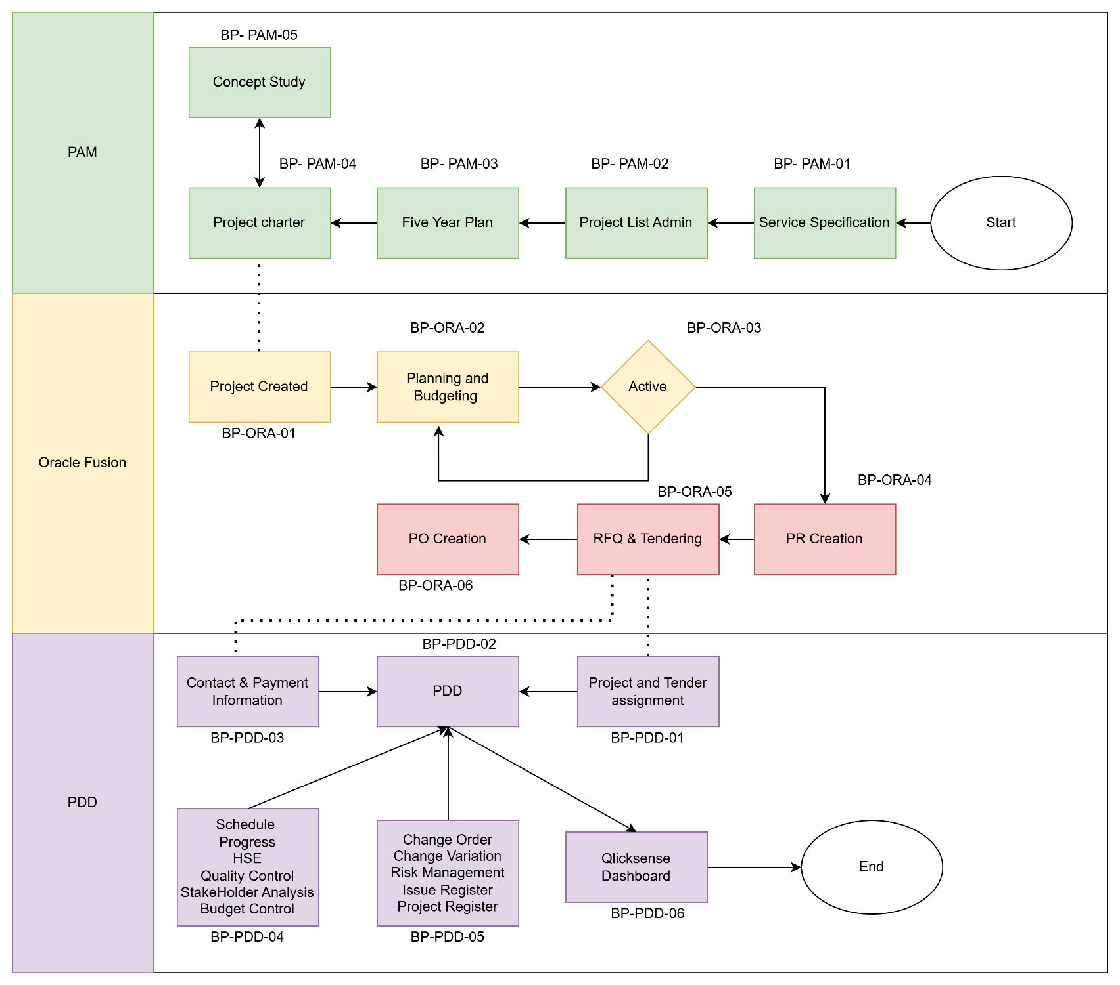

Initial Page
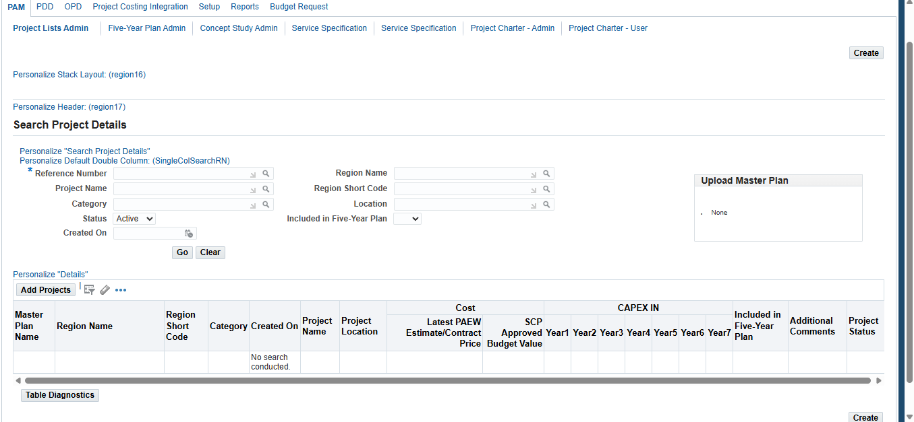

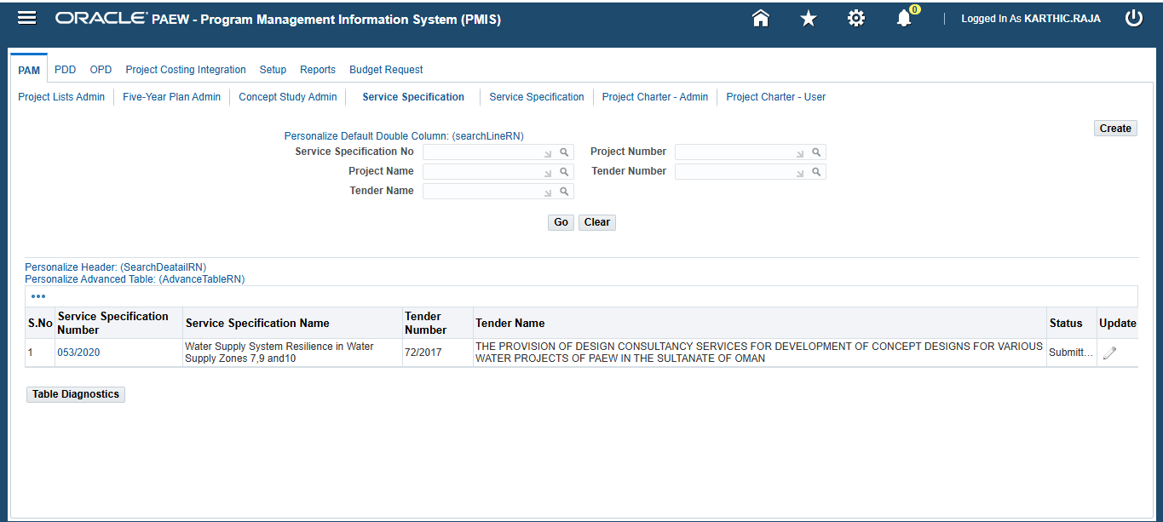

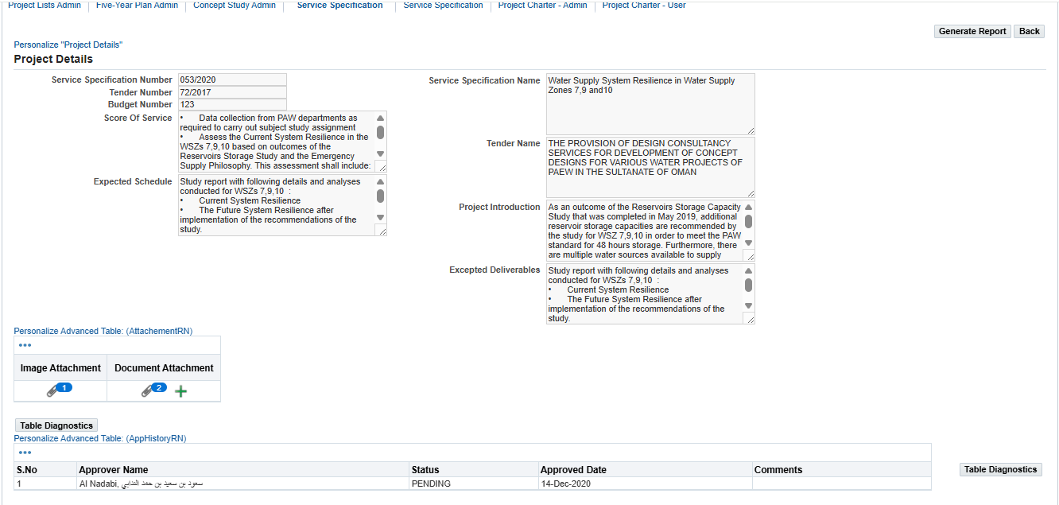

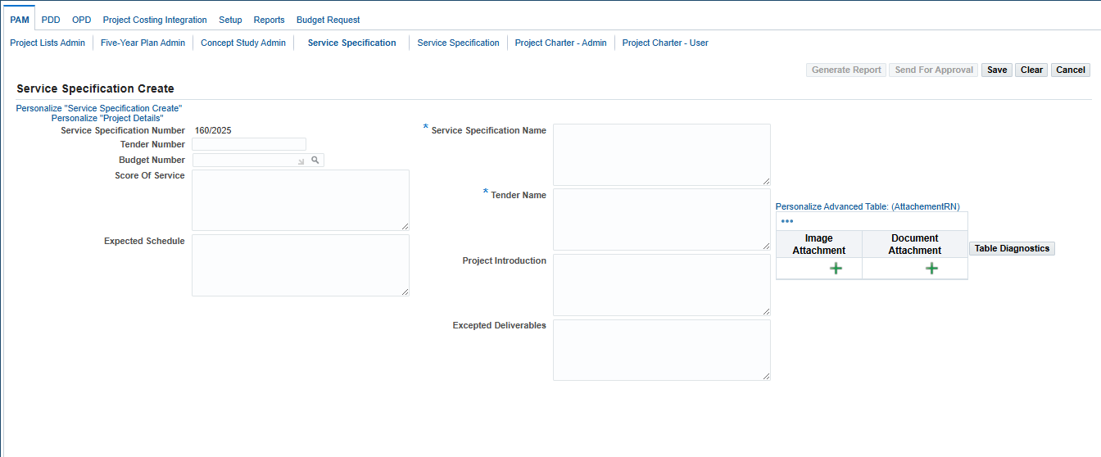

Service Specification

No. | Field / Function | Action | Description
Service Specification
1 | Top Navigation Tabs | Intial | - PAM, PDD, OPD, Project Costing Integration, Setup, Reports, Project Creation.
2 | Sub-navigation Links | Initial | Project Lists Admin, Five-Year Plan Admin, Concept Study Admin, Service Specification, Project Charter - Admin, Project Charter - User.
3 | Service specification | Initial Search | - Service Specification no: Lov with Search Icon  - Project Name: Lov with Search Icon  - Project Number: Lov with Search Icon  - Tender name: Lov with Search Icon  - Tender number: Lov with Search Icon  Two buttons to search and clear  Button on Top Right: Create  Bottom Search results with table format having the information below:  S.no Specification Number Specification Name Tender Number Tender Name Status Update
3 | Service specification | Search Results | - Service Specification no: Lov with Search Icon  - Project Name: Lov with Search Icon  - Project Number: Lov with Search Icon  - Tender name: Lov with Search Icon  - Tender number: Lov with Search Icon  Two buttons to search and clear  Button on Top Right: Create  Bottom Search results with table format having the information below:  S.no Specification Number Specification Name Tender Number Tender Name Status Update  1 Hyperlink of service specification Number Specification name Tender number Tender name Approval status Pencil icon to update
 | Service specification | Opening Search Results | Generate report and Back Buttons on top right of the screen  Feilds on right side:  - Service Specification Number (auto-generated, example: 137/2025)  - Tender Number (free text area)  - Budget Number (LOV-enabled field free test)  - Scope of Service (multiline free text area)  - Expected Schedule (multiline free text area)  Fields on Left side:  - Service Specification Name (mandatory) & (multiline free text area)  - Tender Name (mandatory) & (multiline free text area)  - Project Introduction (multiline free text area)  - Excepted Deliverables (multiline free text area)  Image Attachment  “+” button to upload images  Document Attachment  “+” button to upload files/PDFs/etc.  S.no Approver Name Status Approved date Comments
 | Service Specification | Create | . Buttons (Top Right)  Generate Report (disabled)  Send For Approval  Save  Clear  Cancel  These buttons provide workflow and form-handling options.
4 | Service Specification |  | Feilds on right side:  - Service Specification Number (auto-generated, example: 137/2025)  - Tender Number (free text area)  - Budget Number (LOV-enabled field free test)  - Scope of Service (multiline free text area)  - Expected Schedule (multiline free text area)  Fields on Left side:  - Service Specification Name (mandatory) & (multiline free text area)  - Tender Name (mandatory) & (multiline free text area)  - Project Introduction (multiline free text area)  - Excepted Deliverables (multiline free text area)  Image Attachment  “+” button to upload images  Document Attachment  “+” button to upload files/PDFs/etc.

Project List Admin
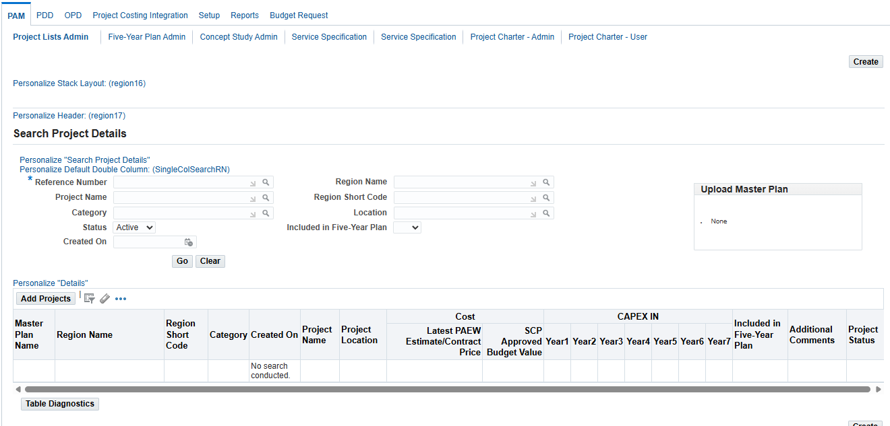

Actions
- create Project List admin
- Search Project List admin

Create service specifications.
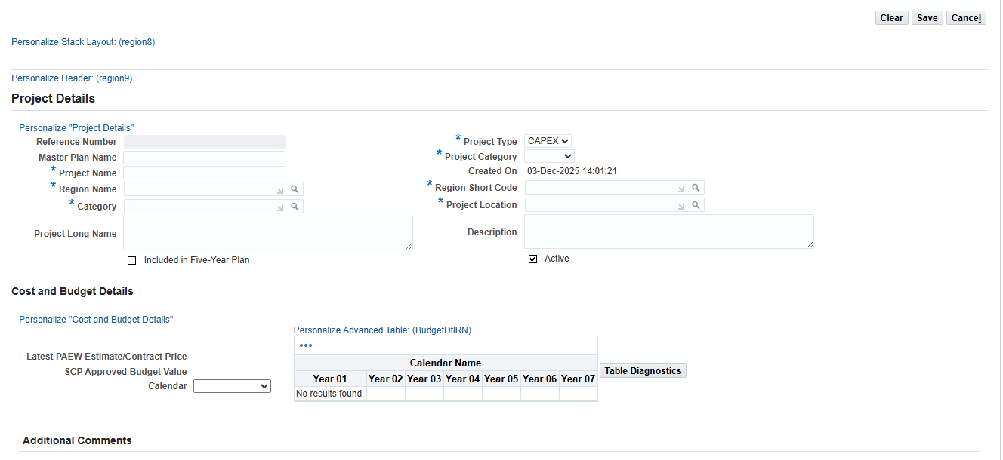

Searching Existing Project list admin as shown in above diagram. System should be capable of opening the existing Project list admin

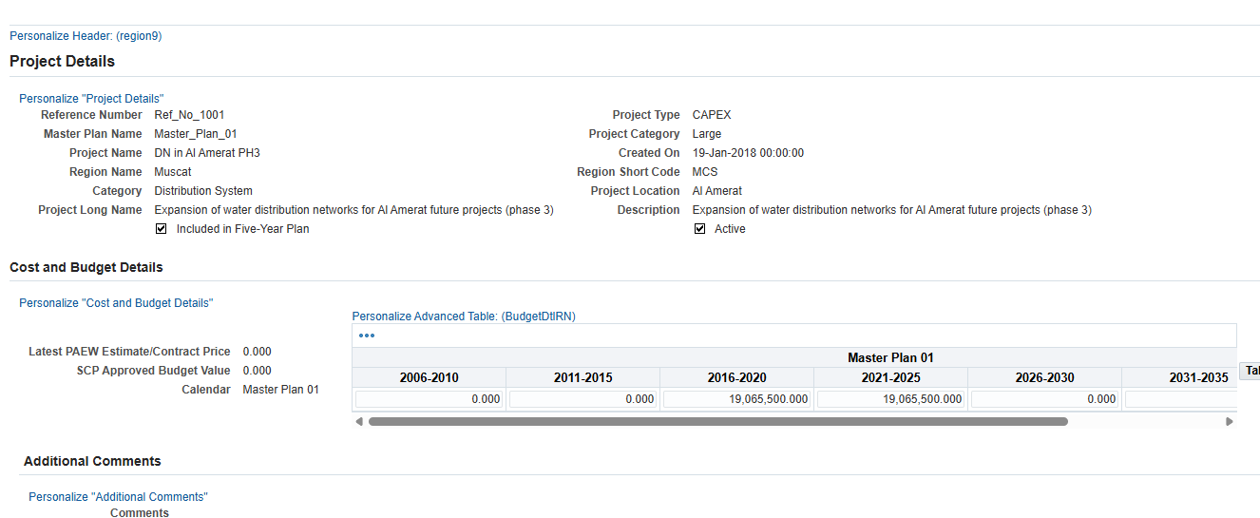

No. | Field / Function | Actions | Description
Project list Admin
1 | Top Navigation Tabs | Initial | PAM, PDD, OPD, Project Costing Integration, Setup, Reports, Project Creation
2 | Sub-navigation Links | Initial | Project Lists Admin, Five-Year Plan Admin, Concept Study Admin, Service Specification, Project Charter - Admin, Project Charter - User.
3 | Project List admin | Main Section: Search Project Details for Service Specification | - Reference Number: Search with LOV and mandatory  - Project Name: Search with LOV  - Region Name: Search with LOV  - Region Short Code: Search with LOV auto selection will happen based on Region and Vice versa  - Category: Search with LOV  - Location: Search with LOV  - Status: Dropdown: Active and Inactive  - Included in Three/ Five-Year Plan: Checkbox  - Created On: Date picker  Buttons: Go and Clear.
4 | Project List admin |  | - Master Plan Name  - Region Name  - Region Short Code  - Category  - Created On  - Project Name  - Project Location  - Latest PAEW Estimate/Contract Price  - SCP Approved Budget Value  - CAPEX IN: Year1, Year2, Year3, Year4, Year5, Year6, Year7  - Included in Five-Year Plan  - Additional Comments  - Project Status  No search conducted (empty table with header Information).  Buttons: create on top and bottom of right corner
5 | Project List admin | Create | Project details header  Buttons: on top right Save, Clear and cancel  Fields on Left  - Reference Number: Auto Populated and mandatory  - Master Plan name  - Project Name:  - Region Name: Search with LOV  - Region Short Code: Search with LOV auto selection will happen based on Region and Vice versa  - Category: Search with LOV  - Include Five years Plan Check Box  Fields on Right  - Project type: Lov Values  - Project Categories: Lov Values  - Created Date: Same date of creation  - Project Location: Lov with Search  - Description: Free text  - Check box Active  Costs and Budget details:  On Left  - Latest PAEW Estimate/Contract Price  - SCP Approved Budget Value  - Calendar: with LOV  On Right:  - 3*3 table with top row with column Name  - 2nd Row with Year 1,2,3,…,7  - 3rd with free text Values  Additional comments with Free text

Five Year Plan
Initial
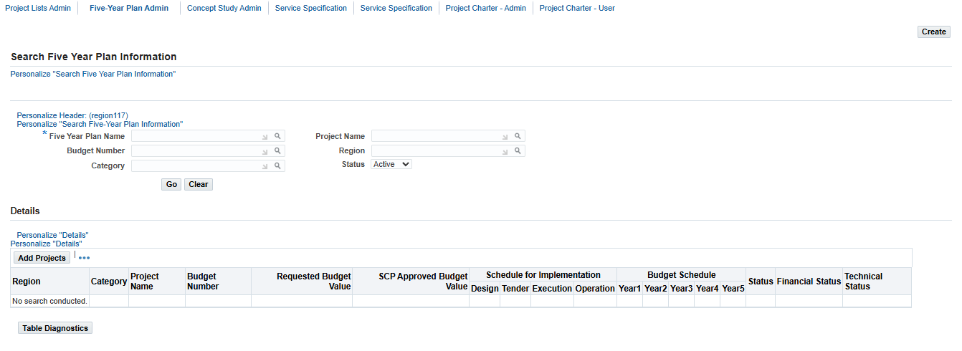
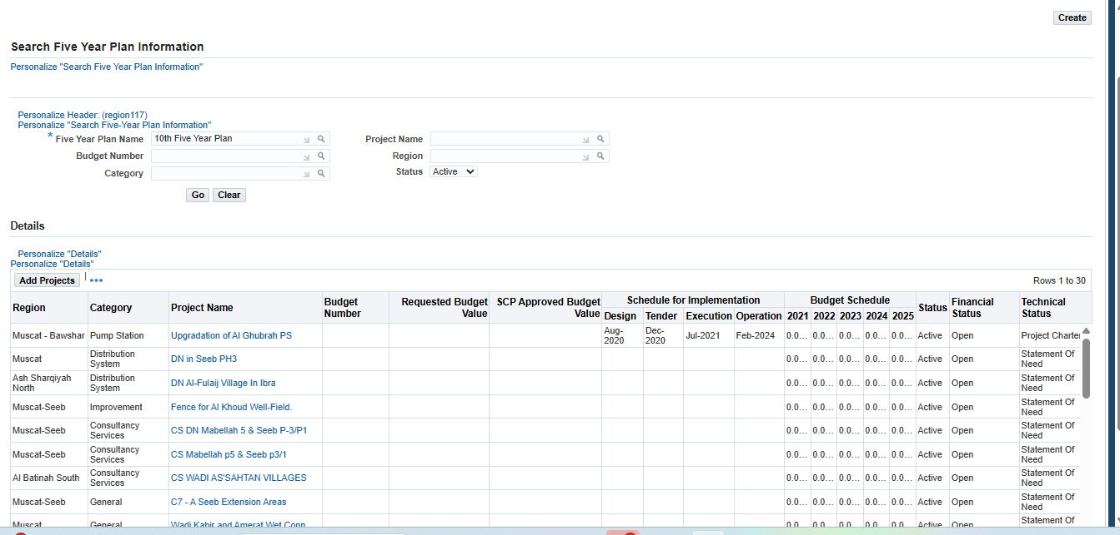

Create:
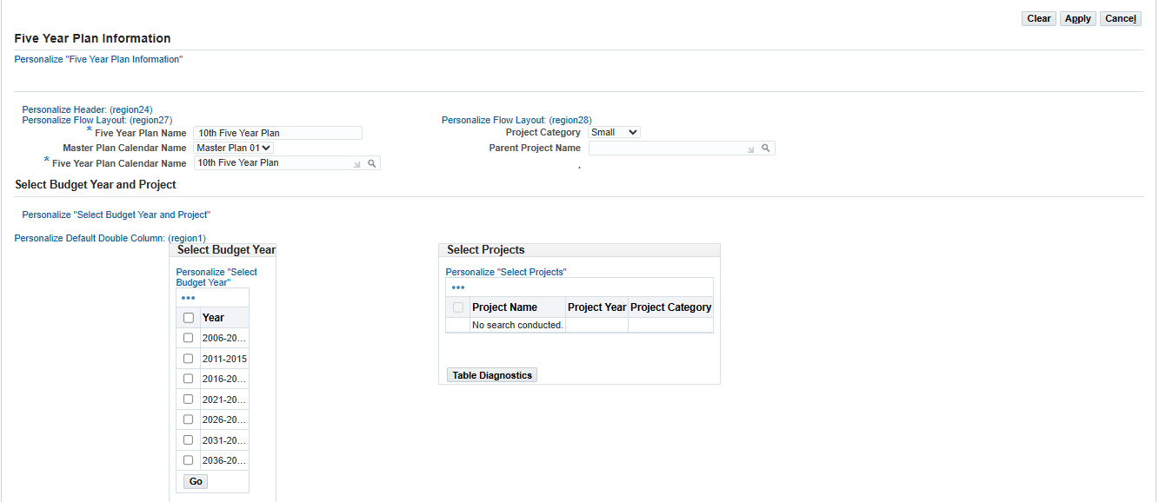

No. | Field / Function | Actions | Description
Five year Plan
1 | Top Navigation Tabs | Initial | PAM, PDD, OPD, Project Costing Integration, Setup, Reports, Project Creation
2 | Sub-navigation Links | Initial | Project Lists Admin, Five-Year Plan Admin, Concept Study Admin, Service Specification, Project Charter - Admin, Project Charter - User.
3 | Five year Paln | Main Section: Search Five year Plan | - Five year Plan Name: With Search Icon and Manditatory  - Budget Number: With Search Icon  - Category: With Search Icon  On Right:  - Project Name: With Search Icon  - Region: With Search Icon  - Status with LOV  - Top Right Corner: Button to create  - Buttons: Go and Clear.  - Search Table information:  - Region  - Category:  - Project Name:  - Budget Number:  - Requested Budget Value:  - SCP Approved Budget value:  - Schedule for Implementation with rows naming Design, Tender, Execution, Operation  - Budget Schedule: with Rows Year1, 2, 3, 4, 5  - Status  - Financial Status  - Technical Status  If No Search was made results will be displayed as empty  If search was made it need to display the table value information
4 | Five-year Plan | Opening Results | Project Information  - Five Year Plan Name: Project Related information  - Project Name: Project Related information  - Category: Project Related information  - Region: Project Related information  - Description: Project Related information  - Project Category: Project Related information  Schedule for Implementation Information  - Official Project Name in English: Free Text  - Official Project Name in Arabic: Free Text  - Estimate Contract Price: Free Text  - Financial Status:  - Technical Status:  On Right  - Design: Lov  - Tender: Lov  - Execution: Lov  - Operation: Lov  - Active Check box  Budget Schedule Information  - MOE Budget Number: Free Text  - Requested Budget Value: Free Text  - MOE Approved Budget Value: Free Text  - Five Year Calendar Name: Value will populate based on search  On Right  2*2 Table with year and capable of capturing amount with free text  Buttons : Save and Cancel  Project Document Information  Concept Study Main Project board approval Project Charter NOCs Other Attachments
5 | Five Year Plan | Add Project/Create | Five Year Plan Information  - Five Year Plan Number: Free Text  - Master plan calendar name: Lov  - Five year plan calendar name: Search List  - Project category: Drop down  - Parent project name: Search List  Select Budget year and Project  Select Budget Year, selection and go button  Available project will be selected in select project area

Project Charter

Project Charter search
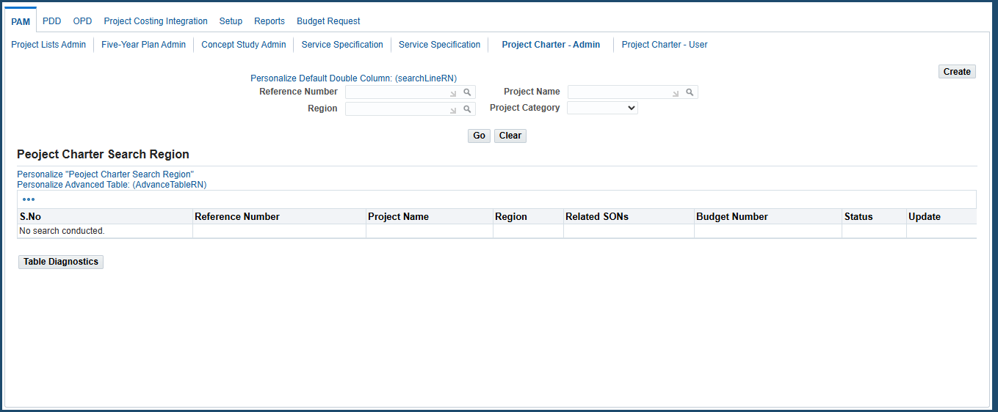
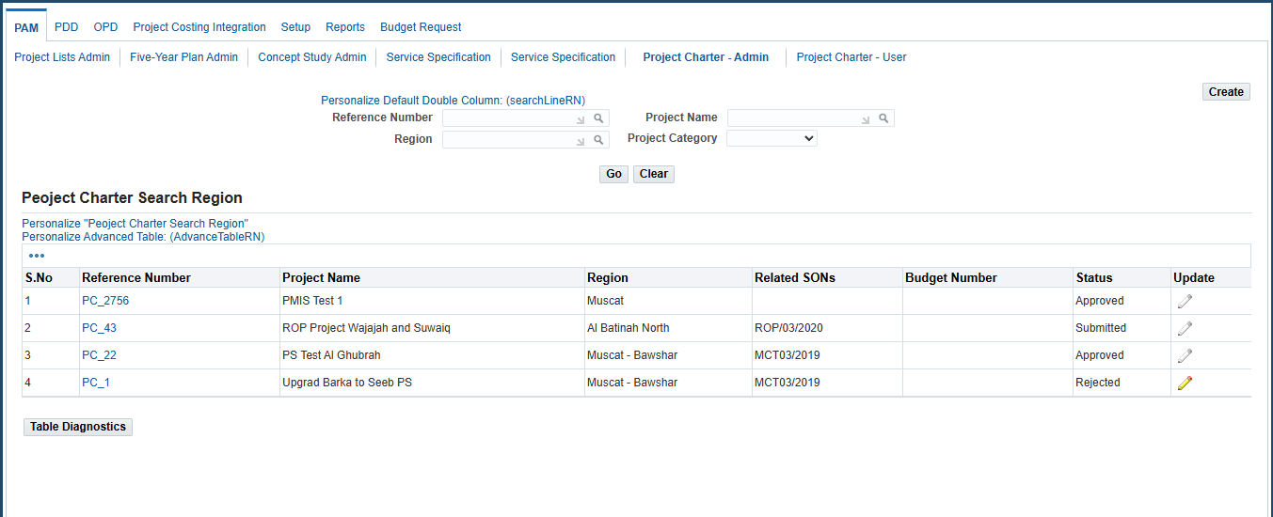

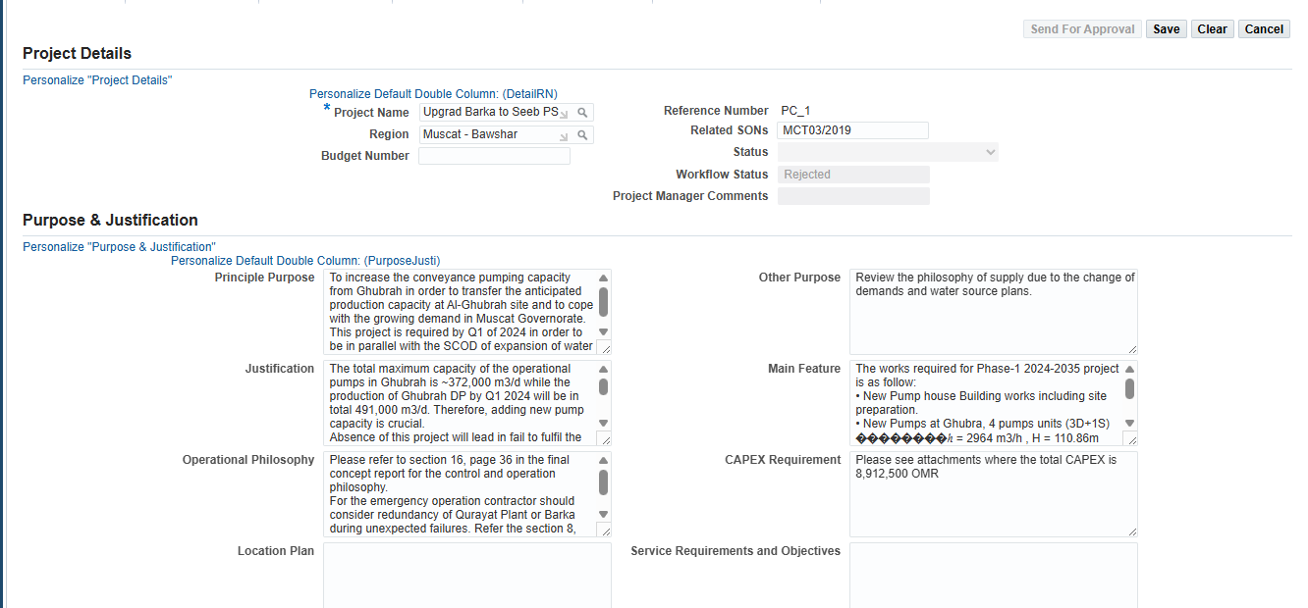

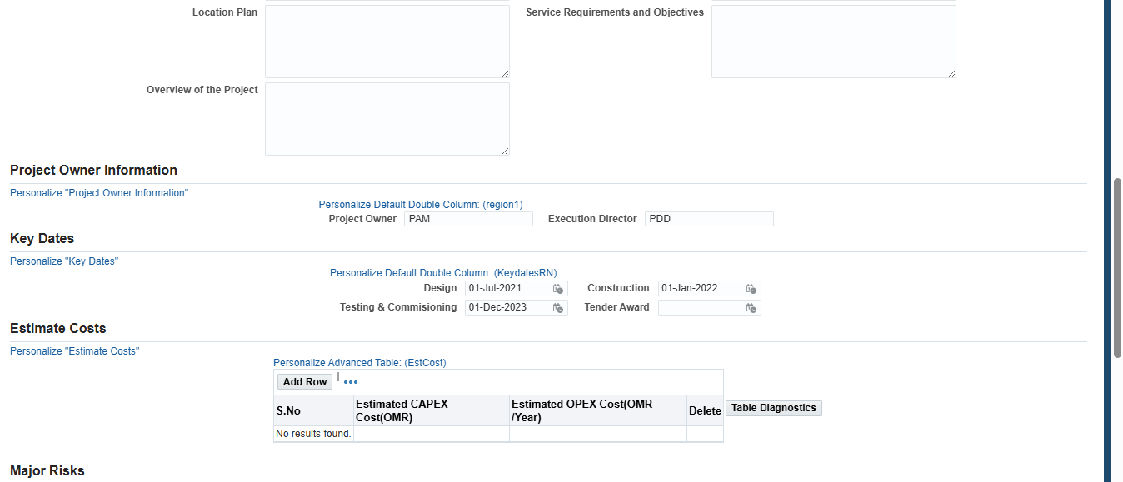

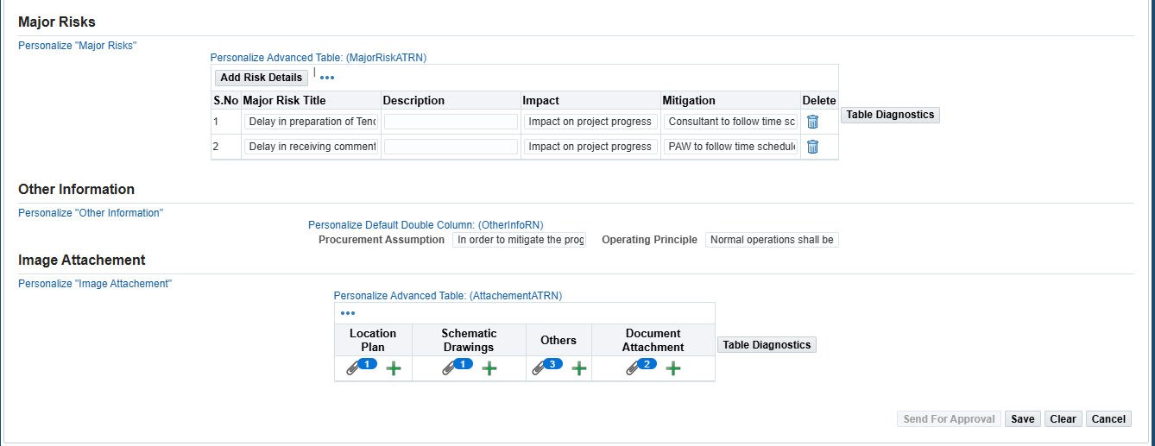

No. | Field / Function | Actions | Description
Project Charter
1 | Top Navigation Tabs | Initial | PAM, PDD, OPD, Project Costing Integration, Setup, Reports, Project Creation.
2 | Sub-navigation Links | Initial | Project Lists Admin, Five-Year Plan Admin, Concept Study Admin, Service Specification, Project Charter - Admin, Project Charter - User.
3 | Project Charter | Main Section: Search Project charter | On Left:  - Reference Number: Search results with values  - Region: Search results with values  - Project Name: Search results with values  - Project Category: LOV  If No Search was made results will be displayed as empty  If search was made it need to display the table value information  Search Results table fields  S.No Reference Number Project Name Region Budget Number Status Update  Create Button On Top Right corner
 | Project Charter | Create/ search values will be same as above sreeen shots | Project Details:  - Project Name: Search Values form search Icon  - Region: Search Values form search Icon  - Status: Lov  - Project Manager comments: Free text  On Right  - Ref Number Auto Generated with PC_Number Format  - Related SONs: Free text  - Budget Number: Free text  - Workflow status: Auto Populated  Purpose & Justification: Below fields are free text and non-editable if you open by search results  Fields to display On Left  - Principle Purpose  - Justification  - Operational Philosophy  - Location Plan  - Overview of the Project  Fields to Display on Right  - Other Purpose  - Main Feature  - CAPEX Requirement  - Service Requirements and Objectives  Project Owner Information  - Project Owner: Free text  - Execution Directors: Free text  Key Dates  - Design: Calendar Date  - Testing & Commisioning: Calendar Date  - Construction: Calendar Date  - Tender Award: Calendar Date  Estimate Costs  Button to Add Rows  S.No Estimated Capex Costs(OMR) Estimated Opex Costs(OMR) Delete  Major Risks  Button To add Risk Details  S.No Major Risk Title Description Impact Mitigation Delete  Other Information  - Procurement Assumption: Free Text  - Operating Principle: Free Text  Image Attachments  - Location Plan: + Icon to add  - Schematic drawings: + Icon to add  - Others: + Icon to add  - Documents Attached: + Icon to add  Button on Tob and right corner: Send for approval, Save, Clear, Cancel

Project Creation

No. | Field / Function | Actions | Description
Project Creation
1 | Top Navigation Tabs | Initial | PAM, PDD, OPD, Project Costing Integration, Setup, Reports, Project Creation
2 | Sub-navigation Links | Initial | Project Creation, Integration History

3 | Project Charter | Main Section: Search Project creation | Project creation  Left Side  - Governorate: Lookup LOV  - Sector: LOV  - Year: LOV  - Sequential numbering: Auto Populate on sequential order  - Asset Type: Lookup LOV  - Work Type: Lookup LOV  Right Side  Template: LOV  Project Name: Free text  Project Number: Sequential Numbering (MCT- W25003-NW-DC)  Project Start date: Select from calendar  Project End date: Select from Calendar  Project Manager: Search icon to find manager  Project Charter Required: Check box Yes/No  If yes Approved or unapproved  Buttons: Cancel and Interface  Governorate: Lookup LOV  - DAK  - DAH  - BAN  - BAS  - BUR  - WUS  - SHN  - SHS  - MCT  - MSM  - COMM  Sector: LOV  - W  - WW  - IN  Year: 2025, 2026 …  Sequential Number: 001, 002, 003…  Asset type:  - NW  - TL  - STP  - RES  - PS  - LS  - DP  - SC  - TFS  - Others  - Multi  Work Type  - CS  - C  - D  - S  - DS  - DC  - PPP

PDD

Project Assignment admin
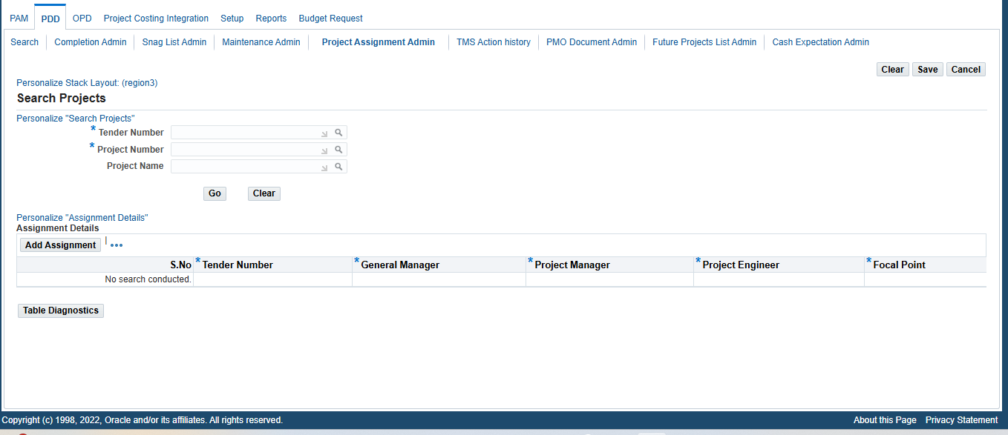

No. | Field / Function | Actions | Description
Project assignment admin
1 | Top Navigation Tabs | Initial | PAM, PDD, OPD, Project Costing Integration, Setup, Reports, Budget Request.
2 | Sub-navigation Links | Initial | Search, Completion Admin, Snag list admin, Maintenance list admin, Project assignment list admin, TMS Action History, PMO Document admin, Future Project List admin, Cash Expectation list admin.
3 | Project Assignment admin | Assignment Search | Completion Search  - Tender Number: Search Icon to populate the field  - Tender Name: Search Icon to populate the field  - Project Number: Search Icon to populate the field  Buttons: Go, Clear  Results in Table format  Column: Tender Name, General Manager, Project Manager, project Engineer, Focal Point  If No search was performed it will show null  If search is performed it needs to populate based on search results  On top of table Button to Add Assignments  Button: Create on top right corner

PDD Search
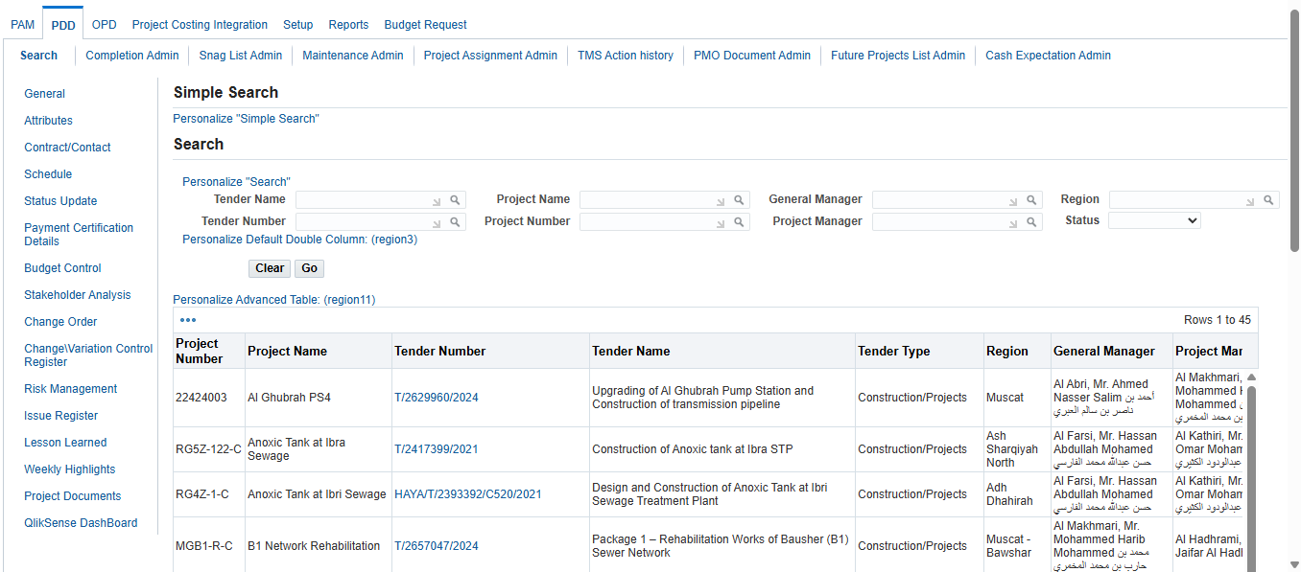
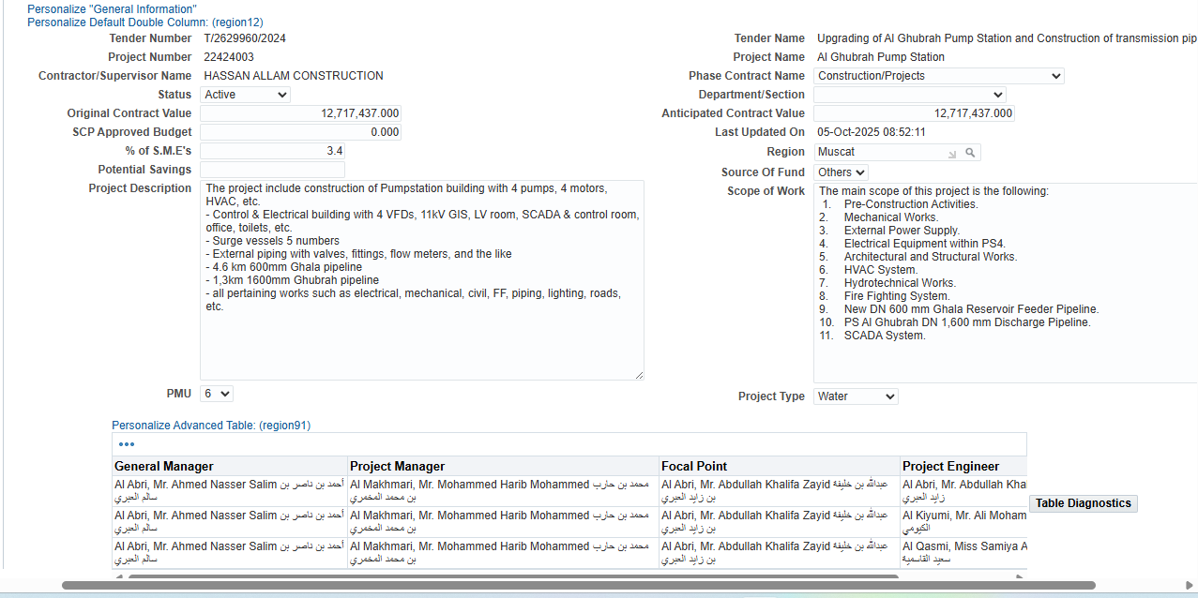
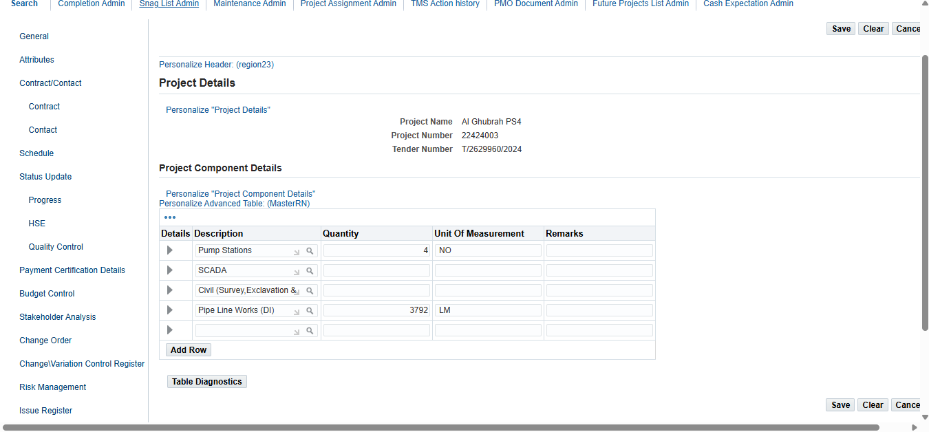
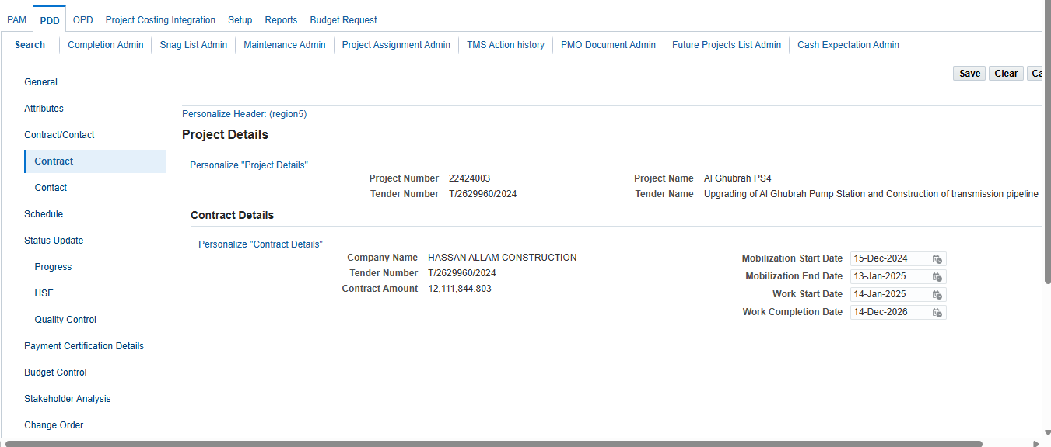
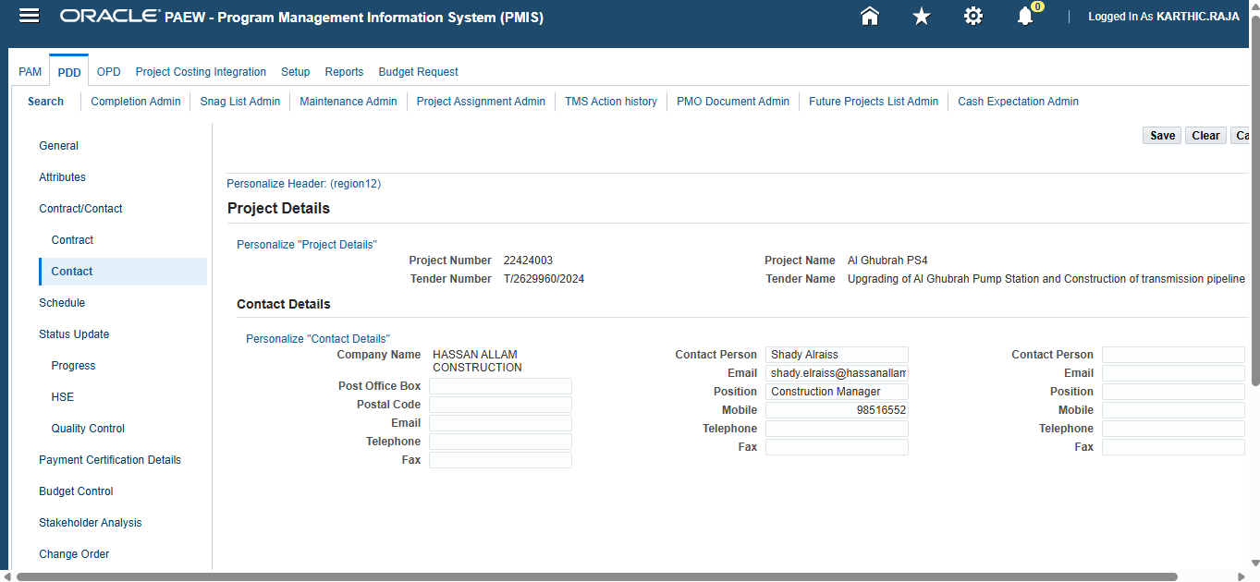

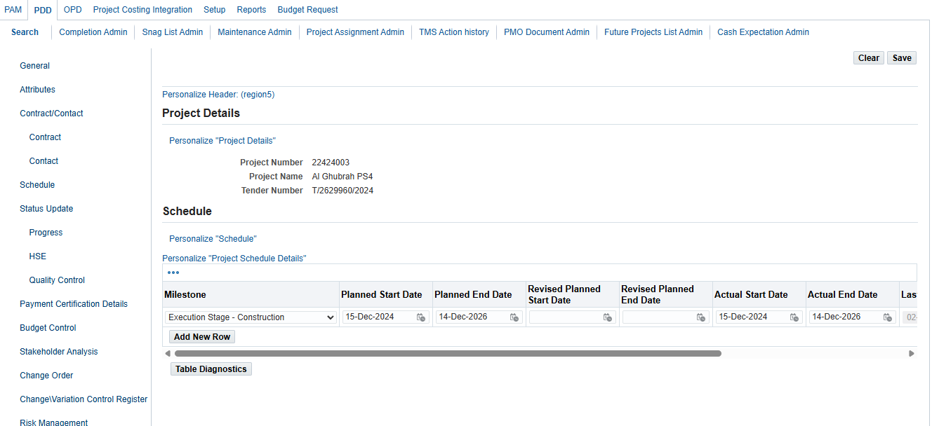

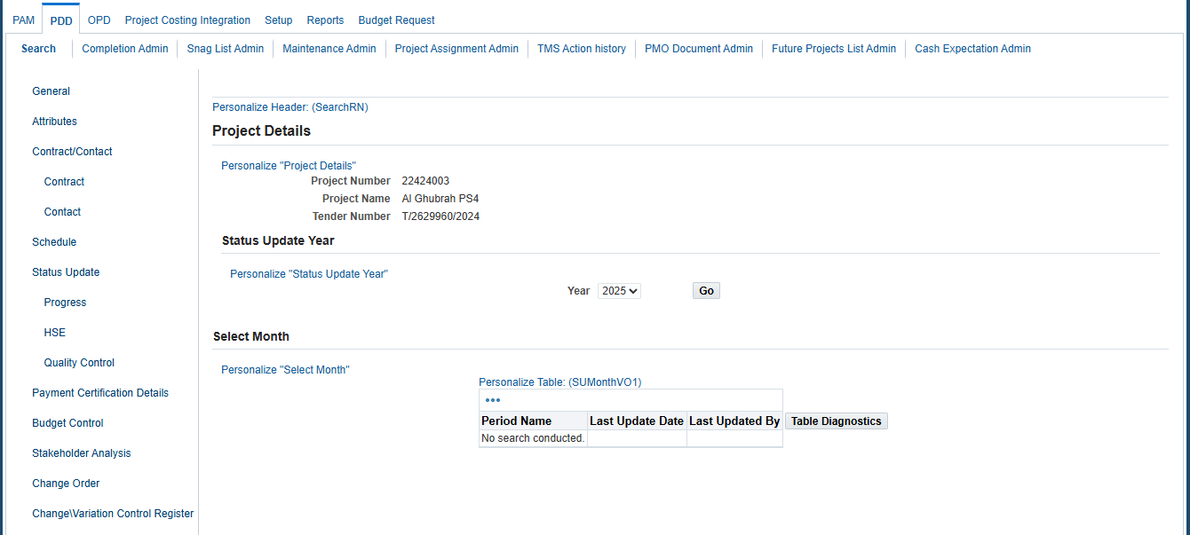
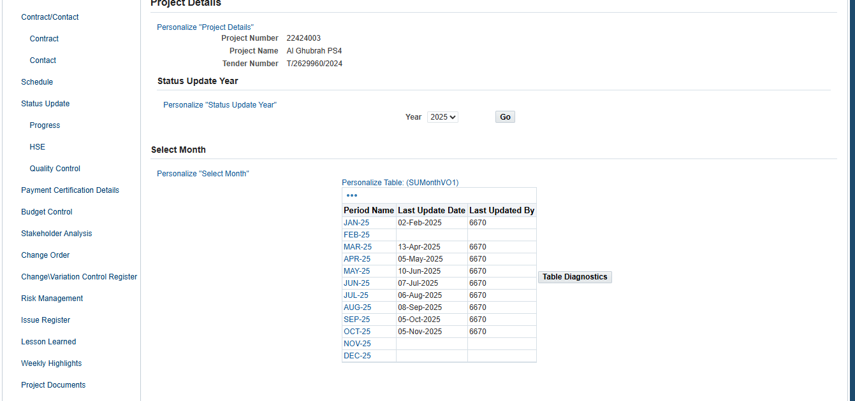
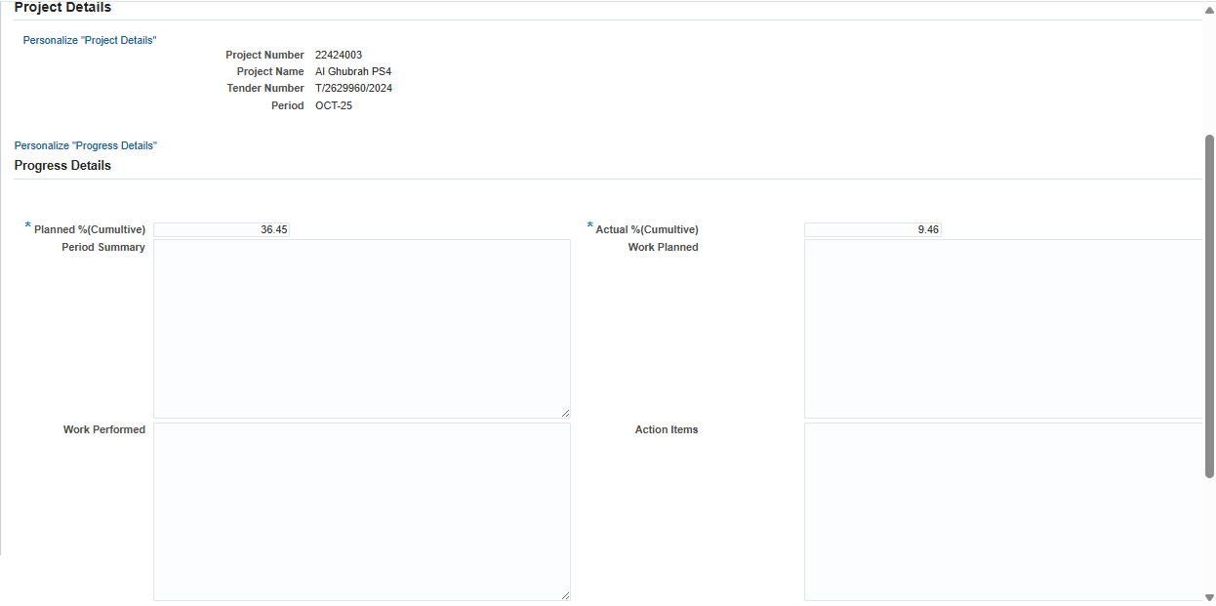

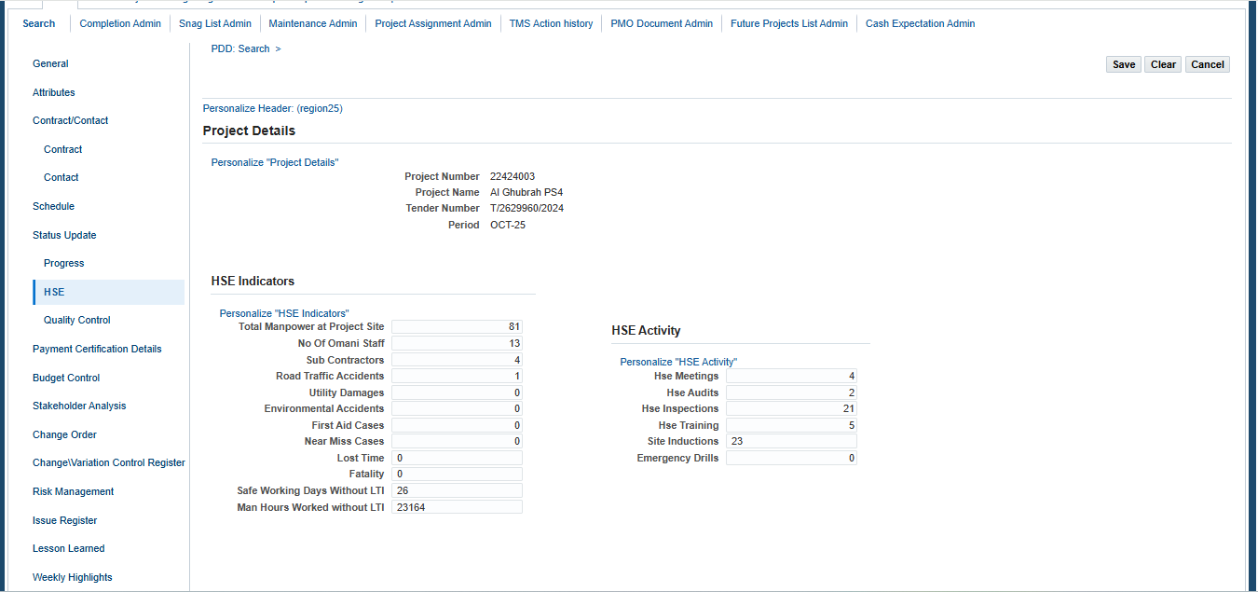
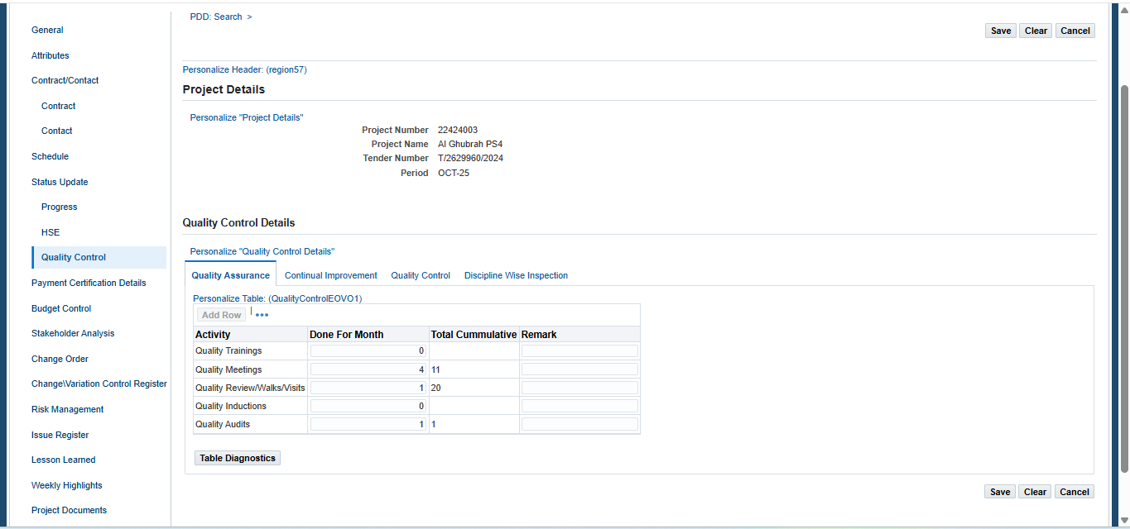
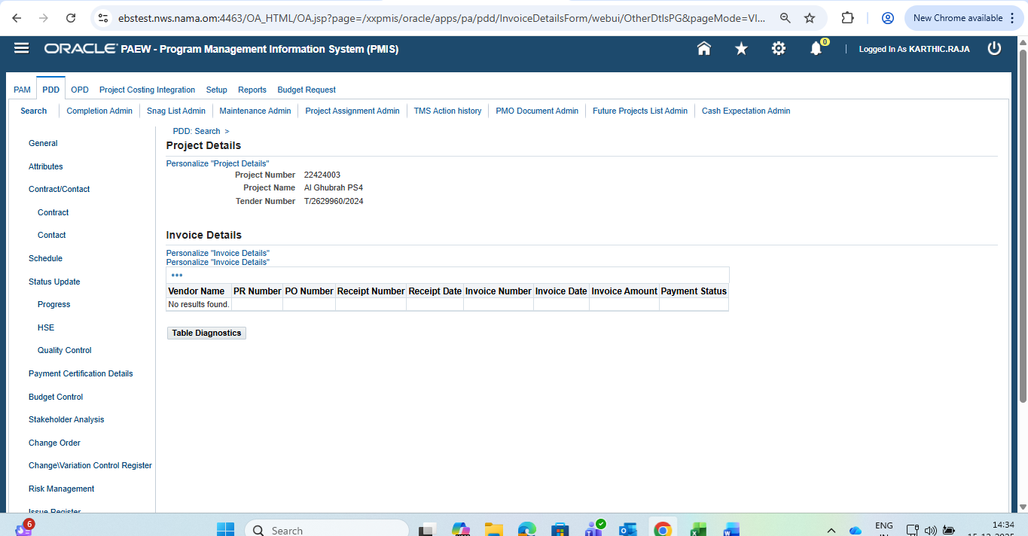
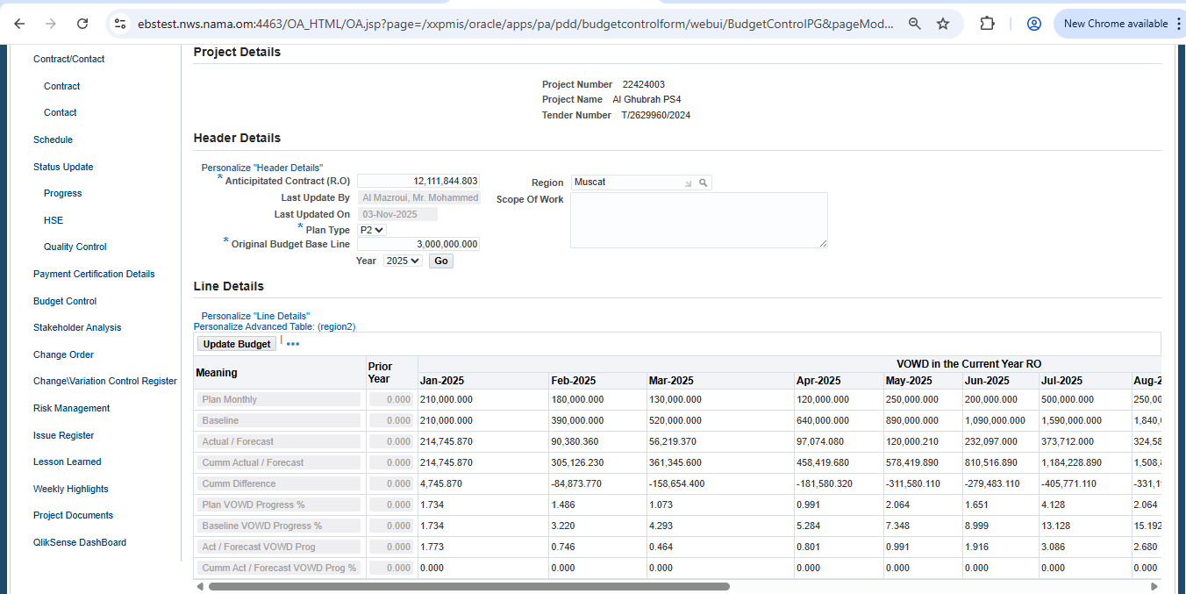

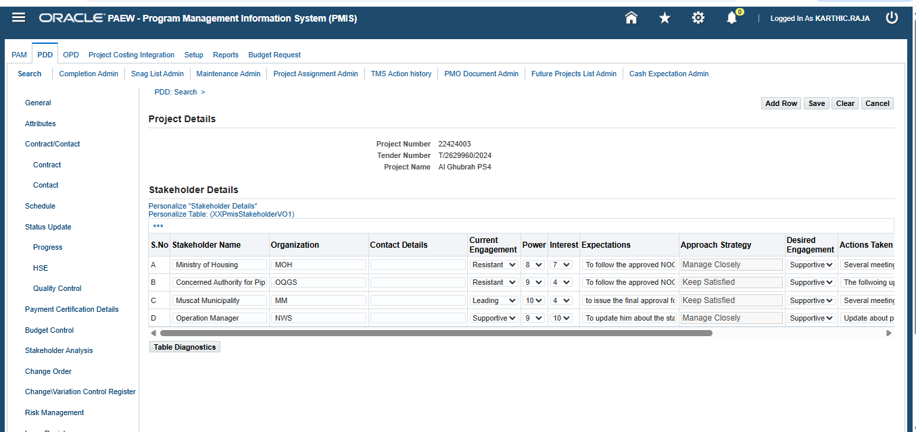

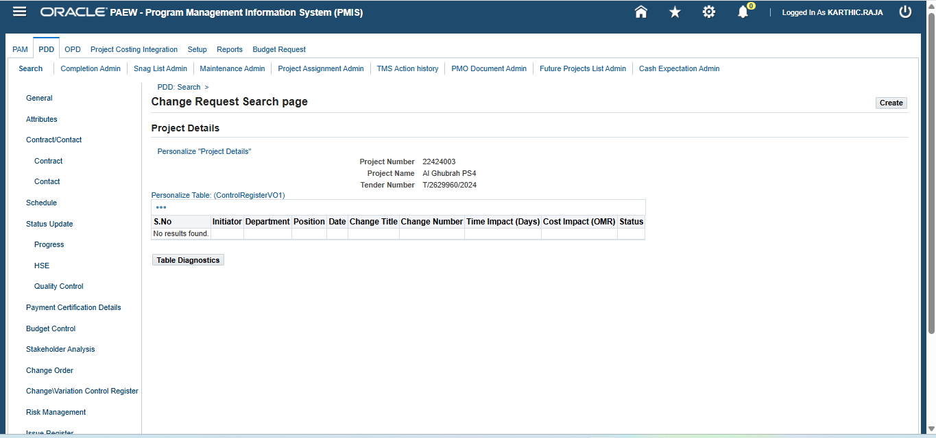

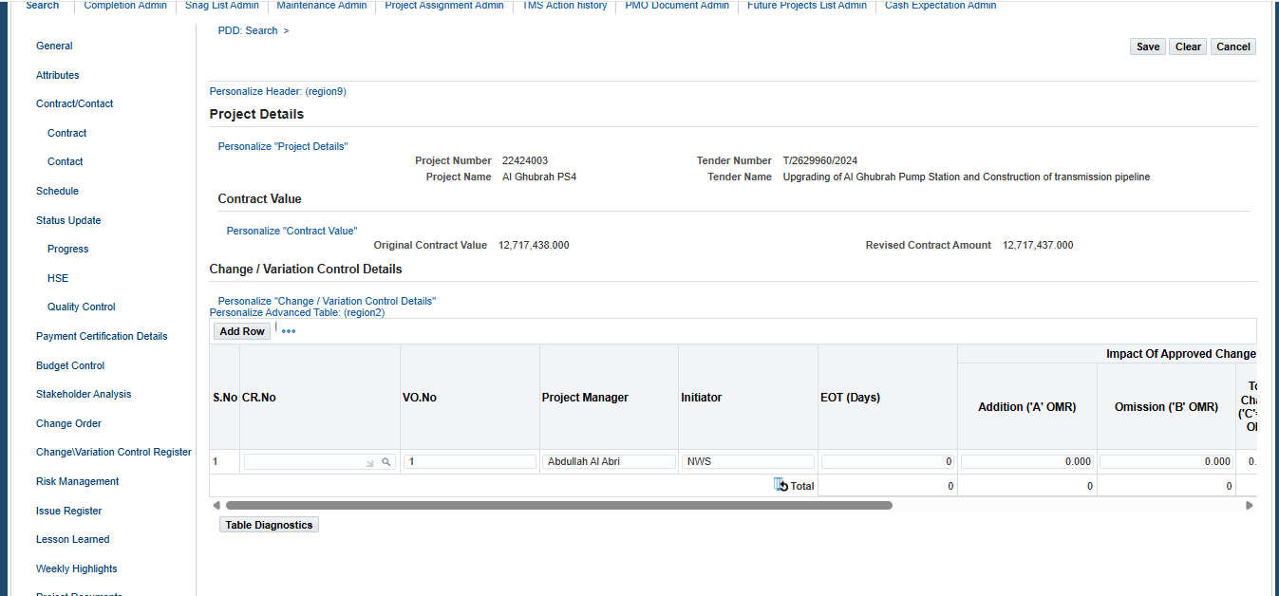

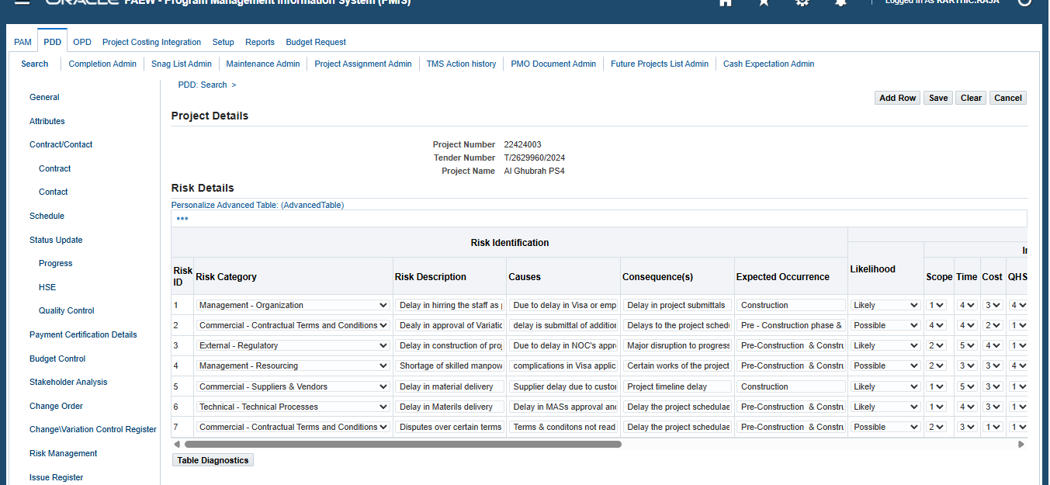

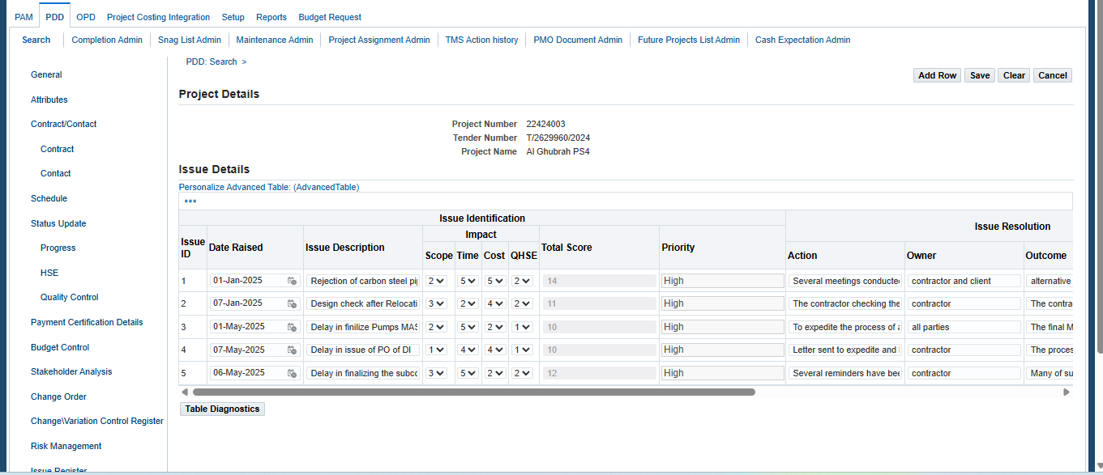

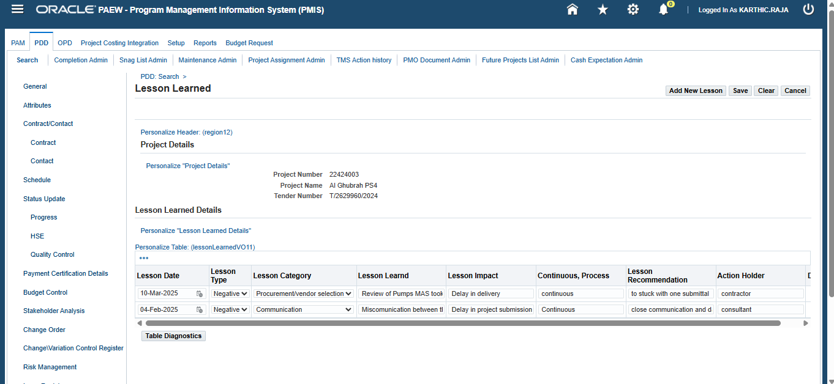

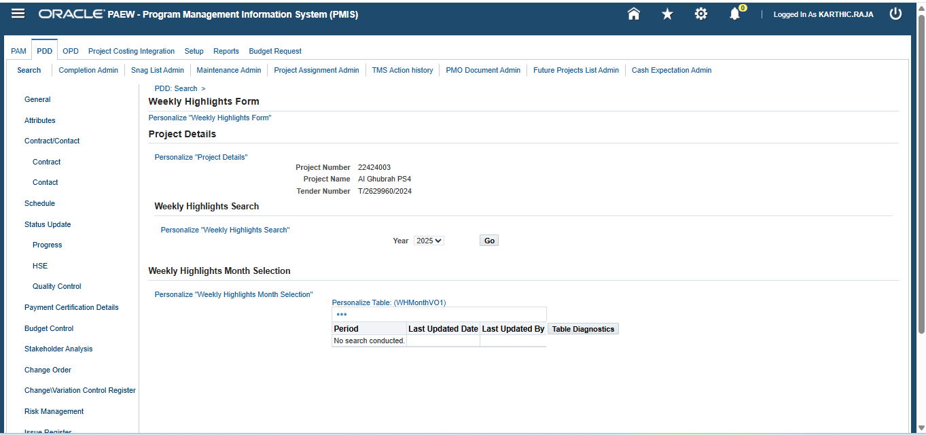
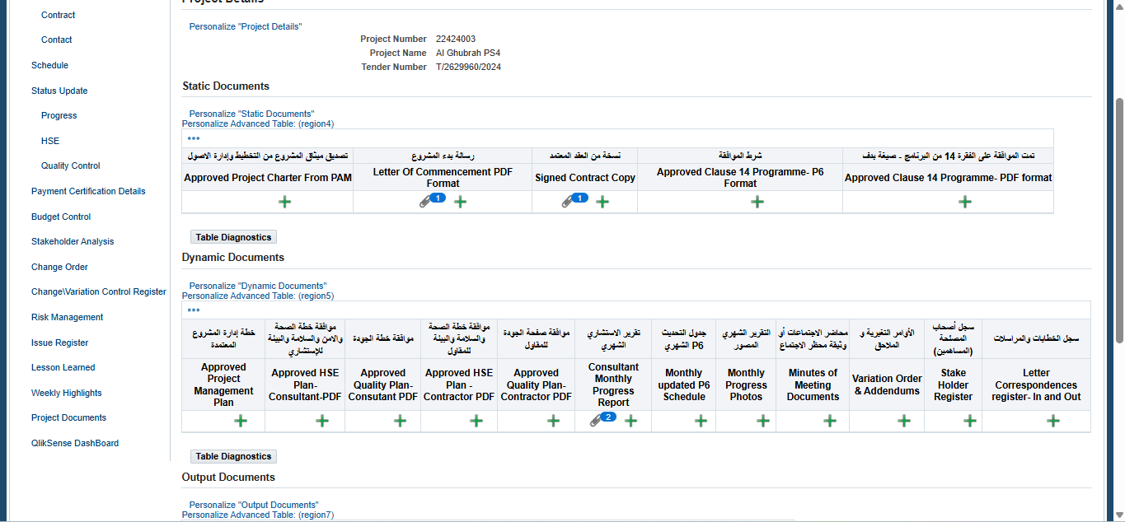
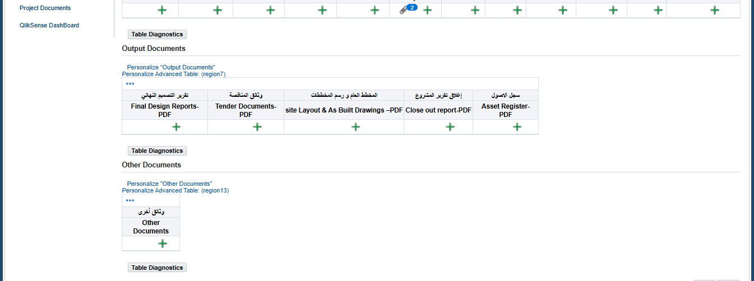

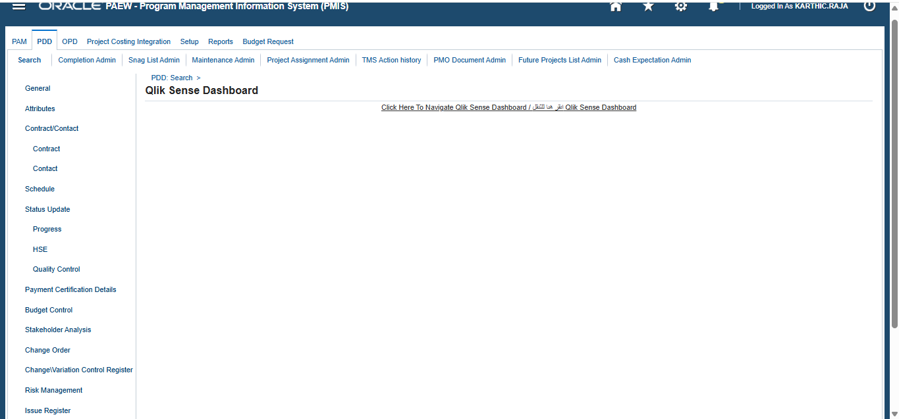

No. | Field / Function | Actions | Description
Project Charter
1 | Top Navigation Tabs | Initial | PAM, PDD, OPD, Project Costing Integration, Setup, Reports, Budget Request.
2 | Sub-navigation Links | Initial | Search, Completion Admin, Snag list admin, Maintenance list admin, Project assignment list admin, TMS Action History, PMO Document admin, Future Project List admin, Cash Expectation list admin.
3 | Left Navigation Links |  | General, Attributes, Contract/Contact, Schedule, Status Update, Payment Certification details, Budget Con troll, Stakeholder analysis, Change Order, Change/Variation Control register, Risk Management, Issue Register, Lesson Learned, Weekly Highlights, Project Documents, Qlik sense Dashboard.
4 | PDD | Main Section: Search PDD Project details | Search:  - Tender Name: Search Icon  - Tender Number: Search Icon  - Project Name: Search Icon  - Project Number: Search Icon  - General Manage: Search Icon  - Project Manager: Search Icon  - Region: Search Icon  - Status: LOV  If No Search was made results will be displayed for 45 Project  If search was made it need to display the table value information  Search Results table fields  Project Number Project Name Tender Number Tender Name Tender Type Region General Manager Project Manager
5 | PDD | General | General Information:  Fields to display on Left  - Tender Number: Based on search it will populate  - Project Number: Based on search it will populate  - Contractor/Supervisor Name: Based on search it will populate  - Status: LOV  - Original Contract Value: Free Text  - SCP Approved Budget: Free Text  - % of S.M.E's: Free text  - Potential Savings: Free Text  - Project Description: Free text  - PMU: LOV  Fields to display on right  - Tender Name: Based on search it will populate  - Project Name: Based on search it will populate  - Phase Contract Name: Lov  - Department/Section: Lov  - Anticipated Contract Value: Free text  - Last Updated On: Last updated date  - Region: Search with values  - Source Of Fund: Lov  - Scope of Work: Free text  - Project Type: Lov  Table to display information of  - General Manager  - Project Manger  - Focal Point  - Project Engineer  On top and button right corner Save and Close buttons
6 | PDD | Attributes | Project Details  - Project Name: Based on search it will be populated  - Project Number: Based on search it will be populated  - Tender Number: Based on search it will be populated  Project Components Details  Table format to populate the Description, Quantity, Unit of Measurements, Remarks  Buttons: To Add Rows next to tables  On top and button right corner Save, Clear and Close buttons
7 | PDD | Contract | Project Details  - Project Name: Based on search it will be populated  - Project Number: Based on search it will be populated  - Tender Number: Based on search it will be populated  Contract Details  - Company Name: Based on Project this value will populate  - Tender Number : Based on Project this value will populate  - Contract Amount: Based on Project this value will populate  - Mobilization Start Date: From Calendar to select  - Mobilization End Date: From Calendar to select  - Work Start Date: From Calendar to select  - Work Completion Date: From Calendar to select  On top and button right corner Save, Clear and Close buttons
8 | PDD | Contact | Project Details  - Project Name: Based on search it will be populated  - Project Number: Based on search it will be populated  - Tender Number: Based on search it will be populated  Contact Details  Left Side: From Vendor information it is going to populate and free text too  - Company Name  - Post Office Box  - Postal Code  - Email  - Telephone  - Fax  Middle: From Vendor information it is going to populate and free text too  - Contact Person  - Email  - Position  - Mobile  - Telephone  - Fax  Right side: From Vendor information it is going to populate and free text too  - Contact Person  - Email  - Position  - Mobile  - Telephone  - Fax  On top and button right corner Save, Clear and Close buttons
9 | PDD | Schedule | Project Details  - Project Name: Based on search it will be populated  - Project Number: Based on search it will be populated  - Tender Number: Based on search it will be populated  Schedules:  Table with below fields:  - Milestone: LOV  - Planned start date: Select from calendar  - Planned end date: Select from calendar  - Revised Planned start date: Select from calendar  - Revised Planned end date: Select from calendar  - Actual Start date: Select from calendar  - Actual end date: Select from calendar  - Last updated date: Auto populated based on the last update  - Remark: Free Text  On top and button right corner Save, Clear buttons
10 | PDD | Status Update | Project Details  - Project Name: Based on search it will be populated  - Project Number: Based on search it will be populated  - Tender Number: Based on search it will be populated  Status Update Year  - Year Lov and Go button  Select Month  Table with all 12 Period Name of the year, Last update date and Last updated by
11 | PDD | Progress | Project Details  - Project Name: Based on search it will be populated  - Project Number: Based on search it will be populated  - Tender Number: Based on search it will be populated  - Period: Based on selection  Progress Details  Fields on Left  - Planned %(Cumultive): Free text  - Period Summary: Free text  - Work Performed: Free text  On Right  - Actual %(Cumultive): Free text  - Work Planned: Free text  - Action Items: Free text  Attachment to add Progress  Botton right corner Save, Clear buttons
12 | PDD | HSE | Project Details  - Project Name: Based on search it will be populated  - Project Number: Based on search it will be populated  - Tender Number: Based on search it will be populated  - Period: Based on selection  HSE Indicators  - Fields to display on LEFT with Free text  - Total Manpower at Project Site  - No Of Omani Staff  - Sub Contractors  - Road Traffic Accidents  - Utility Damages  - Environmental Accidents  - First Aid Cases  - Near Miss Cases  - Lost Time  - Fatality  - Safe Working Days Without LTI  - Man Hours Worked without LTI  On Right side HSE Activity Free text  - HSE Meetings  - HSE Audits  - HSE Inspections  - HSE Training  - Site Inductions  - Emergency Drills  On top right corner Save, Clear and close buttons
13 | PDD | QualityControl | Project Details  - Project Name: Based on search it will be populated  - Project Number: Based on search it will be populated  - Tender Number: Based on search it will be populated  - Period: Based on selection  Quality Control Details:  Four levels of control with sub tabs  - Quality Assurance  - Continual Improvement  - Quality control  - Discipline wise inspection  Quality Assurance  Free text for remaining columns  Activity Done for Month Total cumulative Remarks  Quality Training  Quality meetings  Quality Review/walks/visits  Quality Indicators  Quality audits  On bottom right corner Save, Clear and close buttons  Continual Improvement  Free text for remaining cells  Mechanism type For the month Total Cumulative Pending by open Closed NCR Remarks  Site instructions/Observations  Non-conformities (Identified during the Audits & Inspections) - Consultant initiated  Non-conformities (Identified during the Audits & Inspections) - Client initiated  Non-conformities (Identified during the Audits & Inspections) - Contractor Initiated  External customer complaints  On bottom right corner Save, Clear and close buttons  Quality control  Table with columns fields Type of test, Total for the Month, Satisfactory for the month, Total Cumulative, Satisfied cumulative, Failed cumulative(F), %of failures(F/T)*100%, Major reason for failed test  Table with rows values for Type of test and remaining it is free text, Leak test (for Reservoirs), Disinfection, Coating inspections, Welding inspections (Visual), Pressure test(Hydrostatic Test), Others (incl. of Destructive tests), NDT (RT, UT, MPT etc.), Material Inspections, Field density test, Compaction tests, Concrete test  On bottom right corner Save, Clear and close buttons  Discipline wise inspection  Table with column fields Discipline, Total RFI, Approved RFI, Rejected RFI, Discipline Cumulative (T), Approved discipline Cumulative, Rejected Cumulative (R), % Rejection(R/T)*100, Major reasons for Rejected RFI’s  Row fields: other, Electrical, Mechanical, SCADA, Structural / Civil  On bottom right corner Save, Clear and close buttons
14 | PDD | Payment certification Details | Project Details  - Project Name: Based on search it will be populated  - Project Number: Based on search it will be populated  - Tender Number: Based on search it will be populated  Invoice details  Table format with column names Vendor name, PR Number, PO Number, Receipt Number, Receipt Date, Invoice Number, Invoice date, Invoice Amount, Payment status  Rows will populate based on the transaction against the project
15 | PDD1 | Budget control Page | Project Details  - Project Name: Based on search it will be populated  - Project Number: Based on search it will be populated  - Tender Number: Based on search it will be populated  Header Details:  - Anticipitated Contract (R.O): Free text and mandatory  - Last Update By: Auto update by action performed  - Last Updated On: Auto update by action performed  - Plan type: LOV with P1, P2, P3  - Original Budget Base Line: Free text and mandatory  - Year: LOV with year values  - Region Search  - Scope of Work: Free text  - Button to GO  Line Details  Table with Column details Meaning, Prior Year, VOWD in the current year RO under this Jan to Dec months to be displayed.  Table with row details: Plan Monthly, Baseline, Actual / Forecast, Cumm Actual / Forecast, Cumm Difference, Plan VOWD Progress %, Baseline VOWD Progress %, Act / Forecast VOWD Prog, Cumm Act / Forecast VOWD Prog %  On top of the table one Button – Update Budget  On bottom right corner Save, Clear and close buttons
16 | PDD |  | Project Details  - Project Name: Based on search it will be populated  - Project Number: Based on search it will be populated  - Tender Number: Based on search it will be populated  Stake holder details:  Table with column fields S.No, Stake holder name, Organization, Contact details, Current engagement, Power, Interest, Expectations, Approach strategy, Desired Engagement, Action taken, Action date, Status (Open/Close), Delete  Row A: Stake holder name - Free text, Organization – Free text, Contact details – Free Text, Current engagement – LOV , Power - LOV, Interest - LOV, Expectations – Free Text, Approach strategy - Free Text, Desired Engagement – LOV values, Action taken – Free text, Action date - Select, Status (Open/Close), Delete – Delete Icon  - Current Engagement LOV: Leading, Neutral, Resistance, Supportive, Unaware  - Power LOV: 1 to 10  - Intrest LOV: 1 to 10  - Desired Engagement LOV: Leading, Neutral, Resistance, Supportive, Unaware  - Status LOV: Open/Close  Buttons: Add Rows, Save, Clear, Cancel
17 | PDD1 | Change order | Project Details  - Project Name: Based on search it will be populated  - Project Number: Based on search it will be populated  - Tender Number: Based on search it will be populated  Table with columns header S.No, Initiator, Department, Position, Date, Change title, Change Number, Time Impact (Days), Cost Impact (Days), Status  Create Button on the top right corner  After clicking Create the following information will be available  Project Details  - Project Name: Based on search it will be populated  - Project Number: Based on search it will be populated  - Tender Number: Based on search it will be populated  Change initiator data  - Initiator: Free text and mandatory  - Position: Free text and mandatory  - Department: LOV (Customer service, Others, Operational directorate) and mandatory  - Date: Select from Calendar and mandatory  - Status: Grade out and auto populate  Change details  Number: Auto populate with format CR-0001  Time Impact days (Days): Free text  Description: Free text Mandatory  Relation to Original Scope: Free text and Mandatory  Title: Free text  Cost Impact: free text  Importance and Justification: Free text and Mandatory  Time Frame: Free text  Buttons on top right corner: Save, Submit, Approve, Clear and cancel.
18 | PDD | Change/Varation control Register | Project Details  - Project Name: Based on search it will be populated  - Project Number: Based on search it will be populated  - Tender Number: Based on search it will be populated  - Tender Name: Based on search it will be populated  Contract Value  - Original Contract Value: Auto Populate and not editable  - Revised Contract Amount: Auto Populate and not editable  Change / Variation Control Details  Table format fields with Column names like S.No, CR.No, VO.No, Project Manager, Initiator, EOT (Days), Addition (‘A’ OMR), Omission(‘B’ OMR), Total Change (‘C’=A+B OMR), Net Change (‘D’=A-B OMR), Net Percent Change (A-B/Z), Total Vol. of Change (‘E’=C/Z), Status, If Opened, Remarks.  Table format With row Ex values: S.No = 1, CR.No: Search Icon, VO.No: Free text, Project Manager: Search Icon, Initiator: Free text, EOT (Days): Free Text, Addition (‘A’ OMR): Free text, Omission(‘B’ OMR): Free text, Total Change (‘C’=A+B OMR): Formula Calculation, Net Change (‘D’=A-B OMR): Formula Calculation, Net Percent Change (A-B/Z): Formula calculation, Total Vol. of Change (‘E’=C/Z): Formula Calculation, Status: LOV (Open/Close), If Opened: Lookup, Remarks: Free text.  On the Top of the table a button to add – Add Rows  Buttons: Save, Clear, Cancel on Top and bottom Right corner
19 | PDD | Risk Register | Project Details  - Project Name: Based on search it will be populated  - Project Number: Based on search it will be populated  - Tender Number: Based on search it will be populated  Risk Details  Table Format:  Columns: Risk ID, Risk Category, Risk Description, Causes, Consequences(s), Expected occurrences, Likelihood, Scope, Time, Cost, QHSE, Strength, Overall risk Rating, Under Risk response they are two columns Risk Response Strategy, Preventative/Contingency Action, Monitoring and control Under this column they are again Owner, Action Owner, Expected Retirement, Status, and Delete  Rows:  Risk Id: Sequential Order  Risk Category: Lookup  Risk Description: Free text  Causes: Free text  Consequences(s): Free text  Expected occurrences: Free text  Likelihood: LOV  Scope: 1 to 5  Time: 1 to 5  Cost: 1 to 5  QHSE: 1 to 5  Strength: Free text and once saved grade out  Overall risk Rating: Free text  Under Risk response they are two columns Risk Response Strategy: Lov  Preventative/Contingency Action: Free text  Monitoring and control Under this column they are again Owner: Lov  Action Owner: Free text  Expected Retirement: Select date from calendar  Status: Open, Close and Issue log Lov  Delete: Delete Icon  Buttons: Add Row, Save, Clear, Cancel on Top and bottom Right corner
20 | PDD | Issue Register | Project Details  - Project Name: Based on search it will be populated  - Project Number: Based on search it will be populated  - Tender Number: Based on search it will be populated  Issue Details  Table format:  Columns: Under Issue identification they are Issue ID, Date Raised, issue Description, Impact under this Scope, time, Cost, QHSE, Total Score and Priority. Next Issue Resolution they are Action, Owner, Outcome, Due date of resolution. Issue control under this Resolution in progress update, Progress, Date resolved, Status. And delete  Row: e.x Row 1 :  - Under Issue identification they are Issue ID: Sequential Numbering  - Date Raised: Date of issue raised select from calendar  - issue Description: Free text  - Impact under this Scope:, time, Cost, QHSE: Measeur of 1 to 5 with drop down values  - Total Score and Priority: Free text  - Next Issue Resolution they are Action: Free text  - Owner: Free text  - Outcome: Free text  - Due date of resolution: Select from calendar  - Issue control under this Resolution in progress update: Free text  - Progress: 0, 10, 20, ..., 100  - Date resolved: Select from calendar  - Status: Free text  - Delete: Delete Icon  Buttons: Add Row, Save, Clear, Cancel on Top and bottom Right corner
21 | PDD | Lesson Learned | Project Details  - Project Name: Based on search it will be populated  - Project Number: Based on search it will be populated  - Tender Number: Based on search it will be populated  Lesson Learned Details  Table format  Columns:  - Lesson Learned date  - Lesson type  - Lesson category  - Lesson learned  - Lesson Impact  - Continuous, Progress  - Lesson Recommendation  - Action Holder  - Delete  Rows:  - Lesson Learned date: Date to select  - Lesson type: LOV (Positive or Negative)  - Lesson category: Lookup LOV  - Lesson learned: Free text  - Lesson Impact: Free text  - Continuous, Progress: Free text  - Lesson Recommendation: Free text  - Action Holder: : Free text  - Delete: Icon  Buttons: Add Row, Save, Clear, Cancel on Top and bottom Right corner
22 | PDD | Weekly Highlights | Project Details  - Project Name: Based on search it will be populated  - Project Number: Based on search it will be populated  - Tender Number: Based on search it will be populated  Weekly Highlights Search  - Year Selection with GO Button  Weekly Highlights Month Selection  Table data with column Periods, Last updated date, Last updated by and Row all 12 periods with hyper link and respective details  Once you click the period it will take to another period  Project Details  - Project Name: Based on search it will be populated  - Project Number: Based on search it will be populated  - Tender Number: Based on search it will be populated  Weekly Highlights Entry  Sub tabs: Week1 , 2, 3, 4, 5  Under each week  Left Highlights (Achievements/ Success) and right-side Low light (challenges/ Issue)  Highlights (Achievements/ Success)  - A.Project: free text columns  - B.HSE: Free text columns  Low light (challenges/ Issue)  - A.Project: free text columns  - B.HSE: Free text columns  Buttons: Notify to PMO, Save, Clear, Cancel on Top and bottom Right corner
23 | PDD | Project Documents | Project Details  - Project Name: Based on search it will be populated  - Project Number: Based on search it will be populated  - Tender Number: Based on search it will be populated  Static Documents  Table Format:  Columns:  - Approved Project charter from PAM  - Letter of commencement PDF Format  - Signed contract Copy  - Approved clause 14 programme - P6 format  - Approved clause 14 programme – PDF Format  Rows All with “+” Icon to add  Dynamic Documents  Columns:  - Approved Project management plan  - Approved HSE Plan consultant PDF  - Approved Quality Plan Consultant PDF  - Approved HSE Plan Contractor PDF  - Approved Quality Plan Contractor PDF  - Consultant Monthly Progress report  - Month Update P6 Schedule  - Monthly Progress Photo  - Minutes of Meeting Document  - Variation order/ addendums  - Stake holder register  - Letter correspondence register – In and Out  Rows with + Icon  Output Documents Columns  - Final Design Report – PDF  - Tender document – PDF  - Site Layout & As Built Drawings – PDF  - Close Out report with PDF  - Asset register – PDF  Rows: All with + Icon to add  Other Documents  Table format Other Document in column and + Icon in Row
24 | PDD | ICV | Project Details  - Project Name: Based on search it will be populated  - Project Number: Based on search it will be populated  - Tender Number: Based on search it will be populated  ICV Details  % Of SME: Auto Populate based on calculation  Days Left: Auto Populate based on calculation  %of SME Per Month: Auto Populate based on calculation

Completion Admin
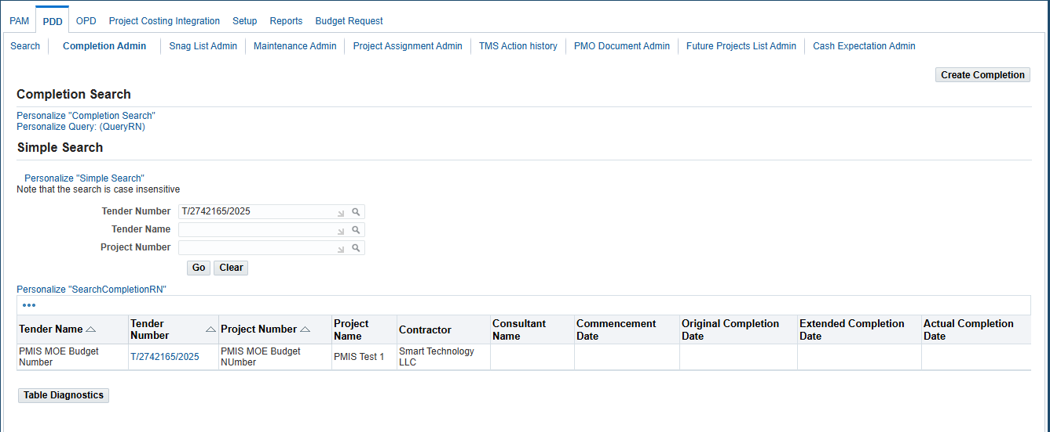

No. | Field / Function | Actions | Description
Completion Admin
1 | Top Navigation Tabs | Initial | PAM, PDD, OPD, Project Costing Integration, Setup, Reports, Budget Request.
2 | Sub-navigation Links | Initial | Search, Completion Admin, Snag list admin, Maintenance list admin, Project assignment list admin, TMS Action History, PMO Document admin, Future Project List admin, Cash Expectation list admin.
3 | Completion Admin | Completion Search | Completion Search  - Tender Number: Search Icon to populate the field  - Tender Name: Search Icon to populate the field  - Project Number: Search Icon to populate the field  Buttons: Go Clear  Results in Table format  Column: Tender Name, Tender Number, Project Number, Project Name, Contractor, Consultant Name, Commencement date, original completion date, Extended completion date, Actual completion date  If No search was performed it will show null  If search is performed it needs to populate based on search results  Button: Create completion on top right corner

Maintenance admin
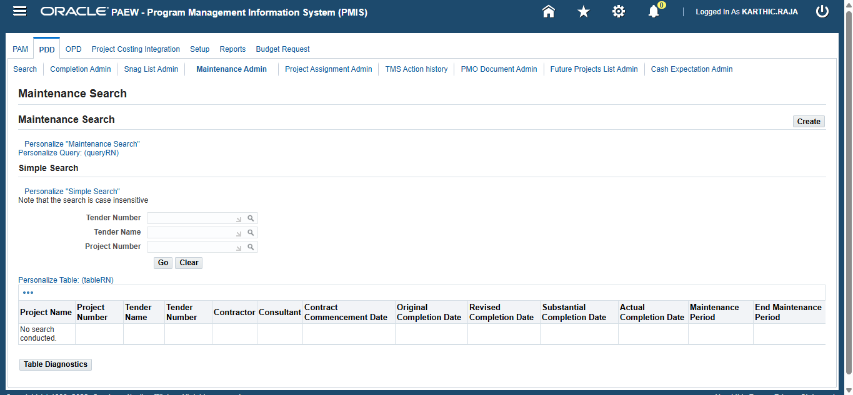

No. | Field / Function | Actions | Description
Completion Admin
1 | Top Navigation Tabs | Initial | PAM, PDD, OPD, Project Costing Integration, Setup, Reports, Budget Request.
2 | Sub-navigation Links | Initial | Search, Completion Admin, Snag list admin, Maintenance list admin, Project assignment list admin, TMS Action History, PMO Document admin, Future Project List admin, Cash Expectation list admin.
3 | Maintenance admin | Completion Search | Completion Search  - Tender Number: Search Icon to populate the field  - Tender Name: Search Icon to populate the field  - Project Number: Search Icon to populate the field  Buttons: Go Clear  Results in Table format  Column: Tender Name, Tender Number, Project Number, Project Name, Contractor, Consultant Name, contract Commencement date, original completion date, Revised completion date, Subsequential completion date, Actual completion date, Maintenance Period, End Maintenance period  If No search was performed it will show null  If search is performed it needs to populate based on search results  Button: Create on top right corner

Open Issues

ID | Issue | Resolution | Responsibility | Target Date | Impact Date

Closed Issues

ID | Issue | Resolution | Responsibility | Target Date | Impact Date

